*DBMS LAB – 01*

1. *Client (clno char(3), clname varchar(30), cladd varchar(40))*

* *PRIMARY KEY- clno*
* *clname can not be left blank*

*SOURCE CODE*

**

*OUTPUT*

*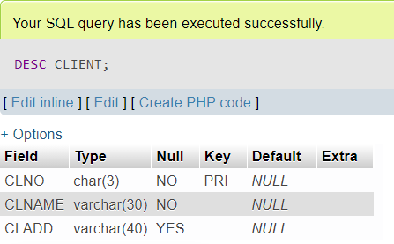*

1. Project (pno char(3), pname varchar(30), pstdate date, clno char(3))

* PRIMARY KEY- pno
* FOREIGN KEY – clno refers to Client relation
* pname can not be left blank

*SOURCE CODE*



*OUTPUT*

1. *Department (dno char(3), dname varchar(20), dloc varchar(20), dhead char(3))*

* *PRIMARY KEY – dno*
* *FOREIGN KEY – dhead refers to eno of Employee relation*
* *dname can not be left blank*
* *default dloc is delhi*

*SOURCE CODE*

*OUTPUT*

*DISPLAY ALL TABLES*

